Building a Campus Study Assistant with Amazon Bedrock (Part 2: Multi-Format Document Parsing & Automated Summarization)
In Part 1, we established our local development environment and verified our connection to Amazon Bedrock using boto3. Now, we take the next steps: turning raw, multi-page coursework PDFs into concise, structured study guides.
We will extract text from PDF files, process large documents cleanly, and send structured prompts to Claude via Bedrock to generate instant summaries and key takeaway lists.

Step 1: Install PDF and docx Processing Libraries
- Run this command in your terminal: “pip install python-docx pypdf”
- It allows both word and pdf documents

Step 2: Prepare Your Study Material
- Add sample notes from your coursework in the “my_coursework_docs” folder

Step 3: Write the Document Analyzer Script
- Create another file called “summarize_pdf.py”
- The script is as shown below:
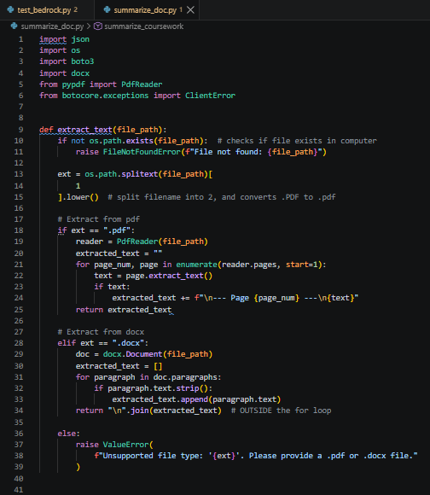
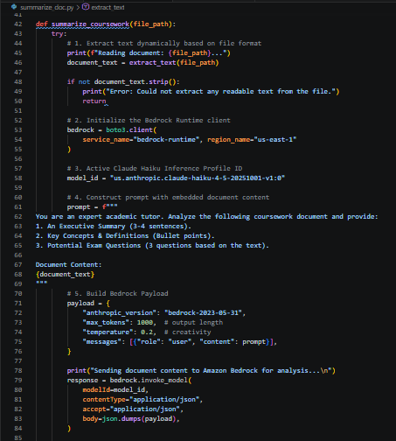

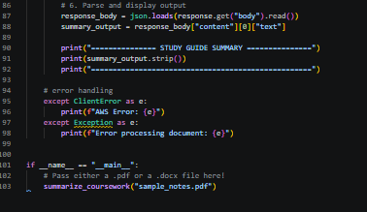

- Script Summary:

[ Your PDF/Word Document]
│
▼ (Phase 1: Local Python opens file & reads text)
[ Plain Text String]
│
▼ (Phase 2: Boto3 sends prompt + text over the internet)
[ Amazon Bedrock / Claude Haiku]
│
▼ (Phase 3: AI generates study guide & sends it back)
[ Study Guide Summary in Terminal]

Step 4: Run and verify:
- Script: “python summarize_pdf.py”
- Expected Terminal output:
Reading document: sample_notes.pdf...
Sending document content to Amazon Bedrock for analysis...
=============== STUDY GUIDE SUMMARY ===============
- Executive Summary:
...
- Key Concepts & Definitions:
...
- Potential Exam Questions:
...
===================================================

- Output as shown below:
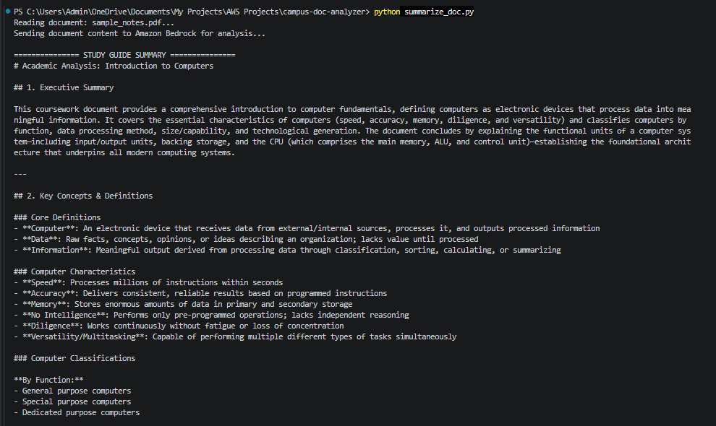

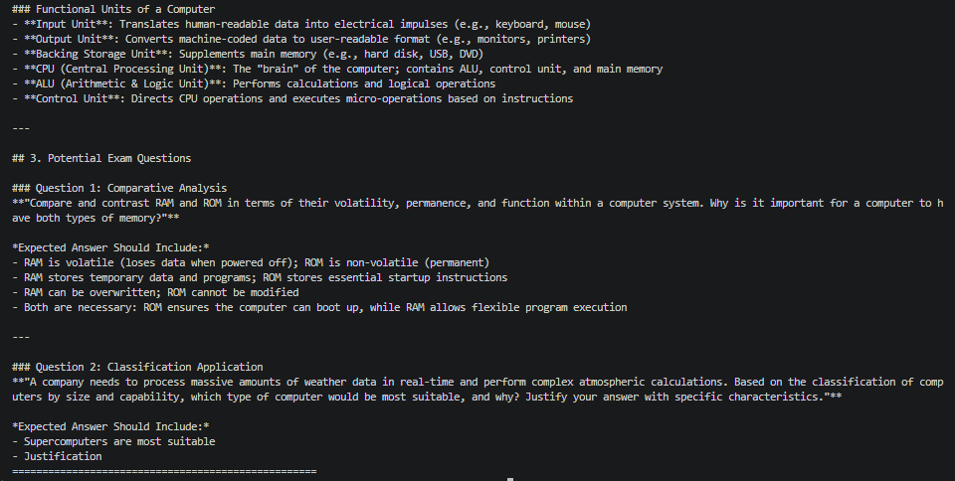

Step 5: Add a simple Web UI (Streamlit)
- For a clean web browser interface
- Add notes in the folder

